Tools Required:

Ms SQL server management studio (for the sql and server)

Visual Studio (for the backend)

Postman

1) After loading in the database into ur Ms SQL server, launch the project inside

2) In solution explorer, under StudentDataAcceS, double click on StudentDataModel.edmx to check if the test database diagram pops out

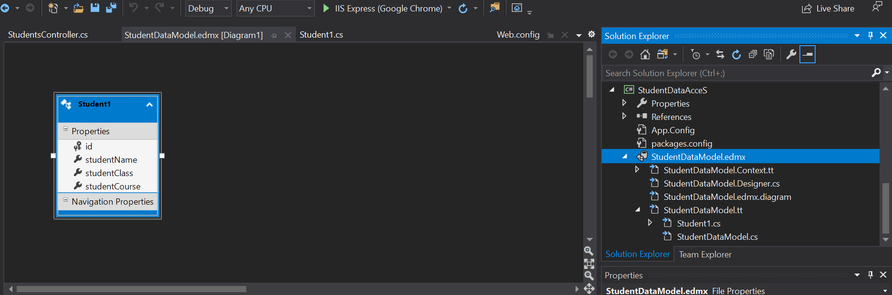

3) If appears, you can then proceed to check StudentsController.cs, located at StonksFinal project, under Controllers (StudentsControllers.cs is where the crud is made)

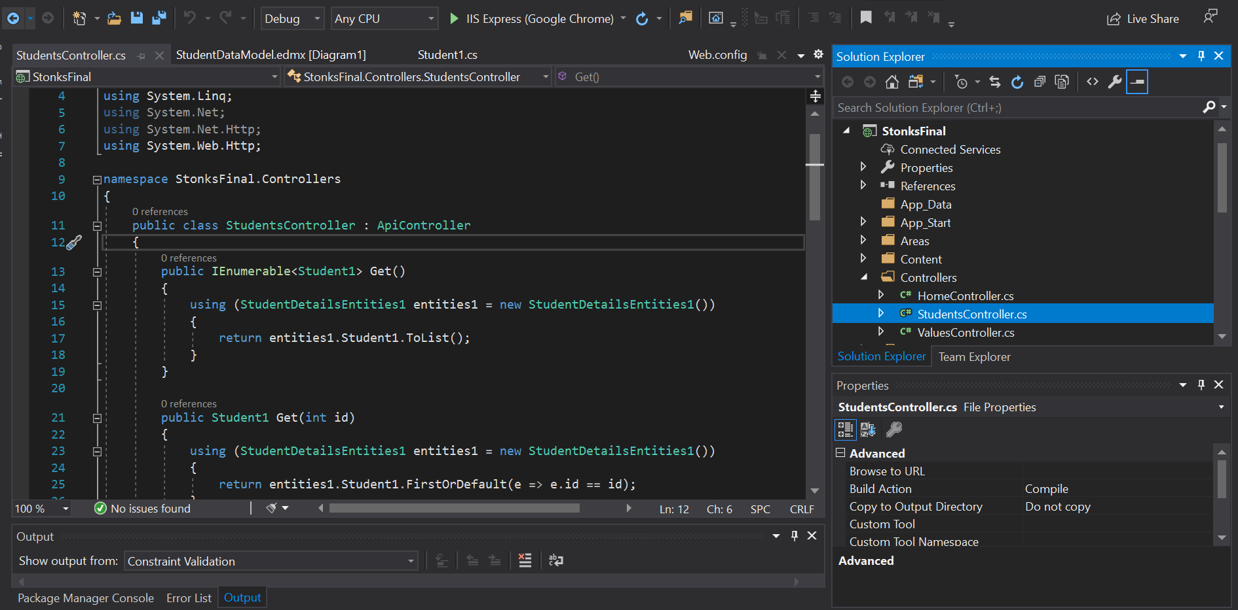

4) If you want to test the api, simply run the project and use postman to test.

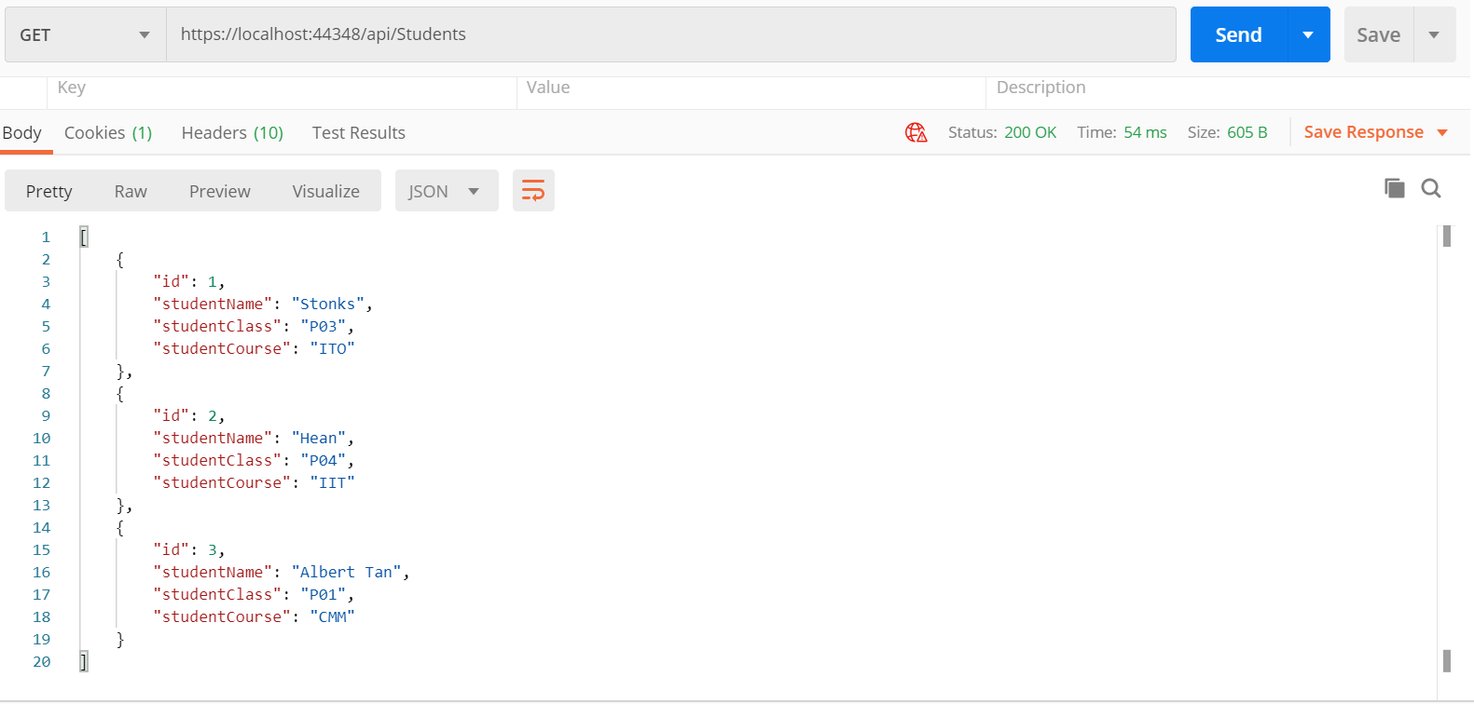

References to how it is done/if u want to try by urself:

Connect MsSQL to asp.net web api project: <https://medium.com/better-programming/building-a-restful-api-with-asp-net-web-api-and-sql-server-ce7873d5b331>

If adding references fail: <https://developercommunity.visualstudio.com/content/problem/51166/referencemanagerpackage-failed-to-load.html>

For PowerShell command, to be used if adding references fail: <https://superuser.com/questions/478679/cannot-cd-to-a-folder-with-spaces-in-the-the-folder-path>

StudentsController CRUD code, making the API: <https://www.c-sharpcorner.com/article/crud-in-web-api-using-sql-server/>

Microservices Week 1 – Developing a Web Service (use the last part where it installs CORS, this is so that postman and ur website can use it)

\*I’ll compile these into a simple labsheet doc tmr\*